**Employee table:**

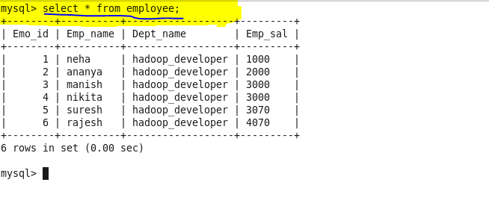

**Incrementing the rows in employee table:**



**Output of incrementing rows in mysql:**

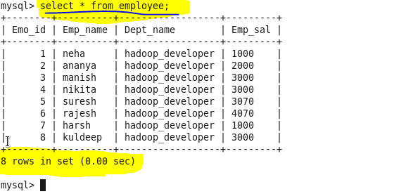

**Data already in hdfs:**

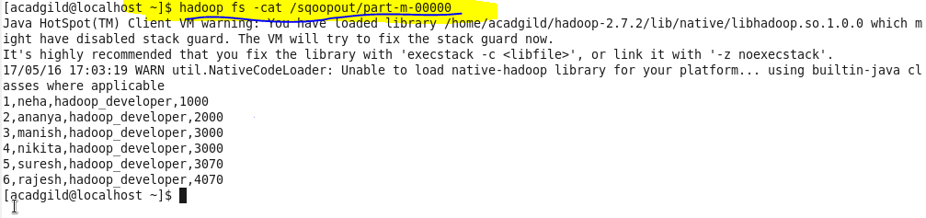

**Importing data from mysql to hdfs:**

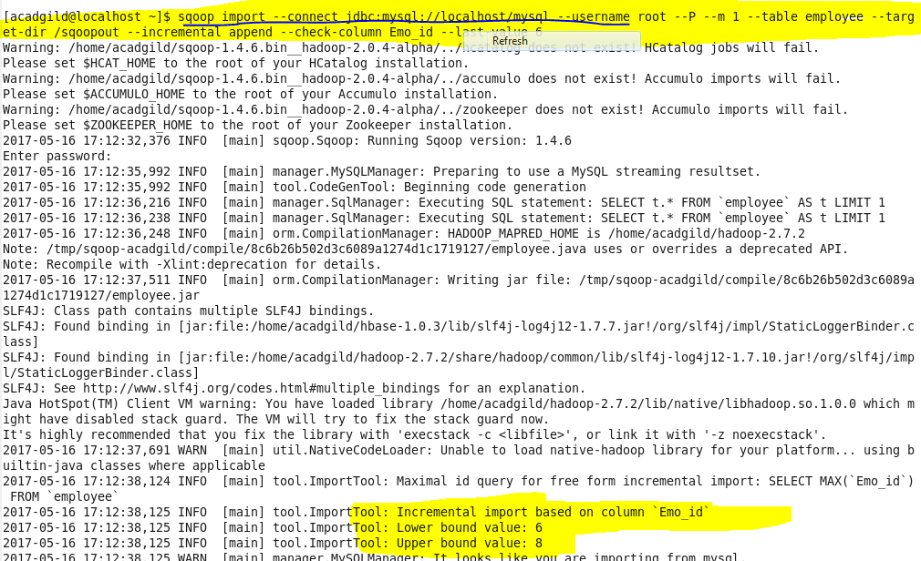

**Completed successfully:**

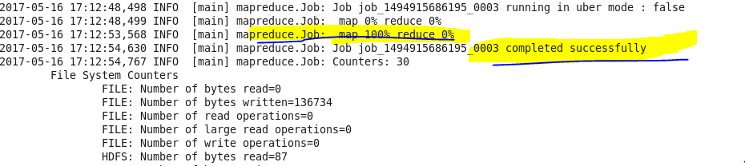

**Increment import completed:**

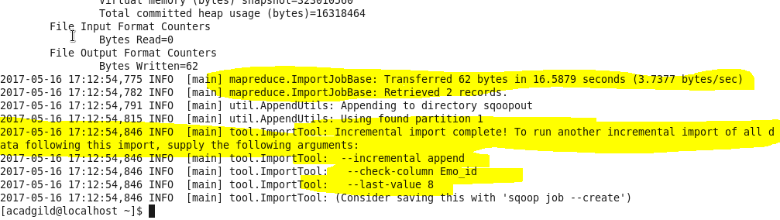

**Output (in hdfs):**

